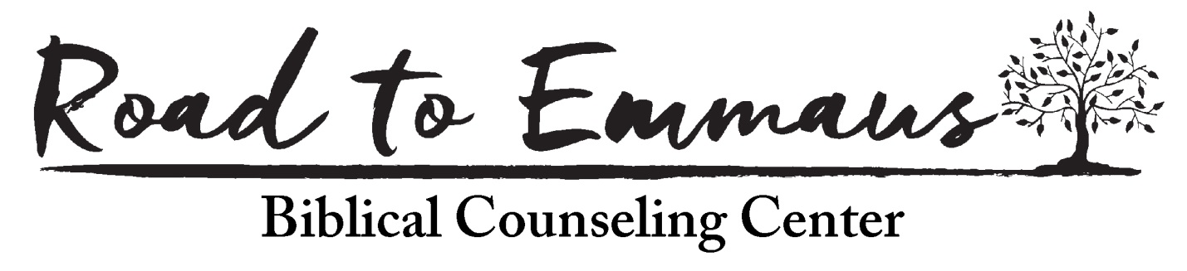
Introducing your teaching team:
Kerry Francetich has been an associate pastor at SW Hills Baptist Church in Beaverton, Oregon since 1989. He is currently the Pastor of Counseling and Care Ministry. He has a bachelor's degree from DeVry Institute of Technology in Phoenix, and worked as an electronics engineer for 6 years before moving to the Portland area in 1984. He attended Western Seminary, earning a Master of Divinity degree in 1989. While attending seminary and shortly thereafter, he taught at Oregon Polytechnic Institute in Portland. He is currently finishing an M.A. in Biblical Counseling at Faith Seminary in Lafayette, Indiana. Kerry lives in Tigard, Oregon with his wife Rosalie, who is also an ACBC certified counselor. They have four married children and ten grandchildren.
Kerry has over 20 years of Biblical counseling experience, and was ACBC certified in 2008. He is dedicated to helping the hurting through Biblical counseling and to training many Biblical counselors throughout the northwest. He is the Director of The Road to Emmaus Biblical Counseling Center, which is the only center in Oregon certified by ACBC to teach the basic training course.

Pete Steele is a Missionary Pastor with the Northwest Baptist Home Mission. He has served as a volunteer on the SW Bible Church counseling team since 2009. He has been counseling and serving in ministry for over 25 years, and was certified by ACBC in 2011. He is married to his lovely wife, Deb, who is also an ACBC certified counselor.

Treasure Valley Area Speakers
Bennie Bourn was certified as a Biblical Counselor in early 2020 and received the Marriage Specialization designation later in 2020. He has been married to his wife Amanda for 20 years and has three children. Bennie attends Montana Avenue Baptist Church in Caldwell.

Dave Duron has served as a pastor at Meridian First Baptist Church for 17 years. He and his wife Beth have been married for 32 years. He and Beth have three adult married children, with 9 grandchildren. Dave completed his B.A. in Biblical Studies from the Master’s University in 1990 and also has recently received an M.A. in Biblical Counseling from the Master’s University. He was certified by ACBC in 2019.

Bruce Groves serves as the Pastor of Discipleship at Ambassador Bible Fellowship in Meridian. He is honored to be married to Carol since 1982 and has been blessed with three adult children and six grandchildren. Bruce earned a B.A. in History (UC Riverside) and an M.A. in Biblical Counseling (The Master’s University). He has 30+ years of ministry in Southern California, Tennessee, Northern Indiana and Idaho. He was also involved with three EFCA church plants in San Diego, Nashville, and Meridian. He is a certified ACBC counselor.

Thomas Herringshaw is the Teaching Pastor at Ambassador Bible Fellowship in Meridian. He has been married to Libby since 2010 and they have been blessed with two young children. Thomas earned his M.Div. from The Master’s Seminary in 2013 and has eleven years of ministry experience in various ministries at The Bridge Bible Fellowship and now Ambassador Bible Fellowship. Thomas is a certified biblical counselor with the Association of Certified Biblical Counselors (ACBC).

